**GROUP 9**

**EXPERIMENT 5**

**AIM: DISPLAY ANALOG SENSOR(LM 35) VALUE IN BLYNK APP**

**APPARATUS :**

1. NodeMCU( ESP8266 12E )
2. LM 35 Sensor
3. Breadboard
4. Jumper Wires
5. USB Cable

* **Software Application:** Blynk App

**BLOCK DIAGRAM:**

**Blynk App**

**NodeMCU**

**LM 35**

**Fig:1a**

**EXPLANATION:**

LM35 sensor is connected an Analog pin of NODE MCU which is connected to the BLYNK APP in the Mobile Devices using the Authentication key given during the registration . In the BLYNK APP the Sensor is recognized by a virtual pin where the immediately collected data ( temperature data ) is displayed .

**CODE:**

**#define BLYNK_PRINT Serial**

**#include <ESP8266WiFi.h>**

**#include <BlynkSimpleEsp8266.h>**

**int val;**

**int tempPin = A0;**

**char auth[] = "hosEitmcOMgVentoZ17g0jPdGot_tWYX";**

**char ssid[] = "Codermaker";**

**char pass[] = "babi1pal";**

**void setup() {**

**Serial.begin(115200);**

**pinMode(A0,INPUT);**

**Blynk.begin(auth, ssid, pass);**

**}**

**void loop() {**

**Blynk.run();**

**val = analogRead(tempPin);**

**float mv = ( val / 1024.0) * 3300;**

**float cel = mv / 10;**

**Serial.println(cel);**

**{**

**Blynk.virtualWrite(V0,cel);**

**Blynk.run();**

**delay(1000);**

**}**

**}**

**OUTPUT:**

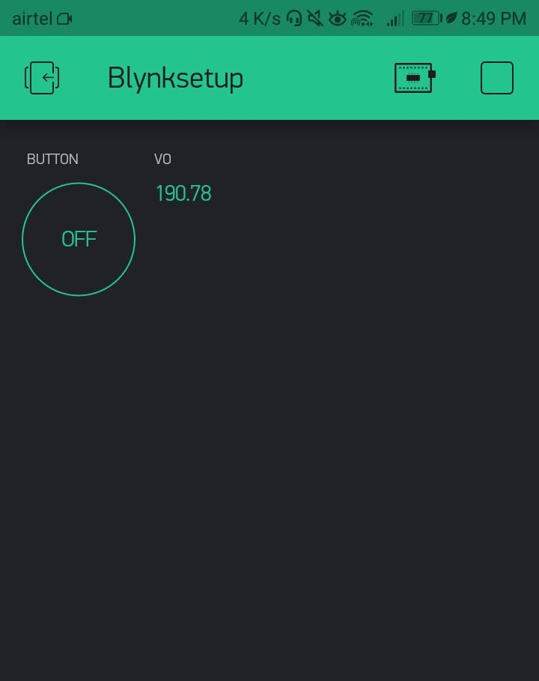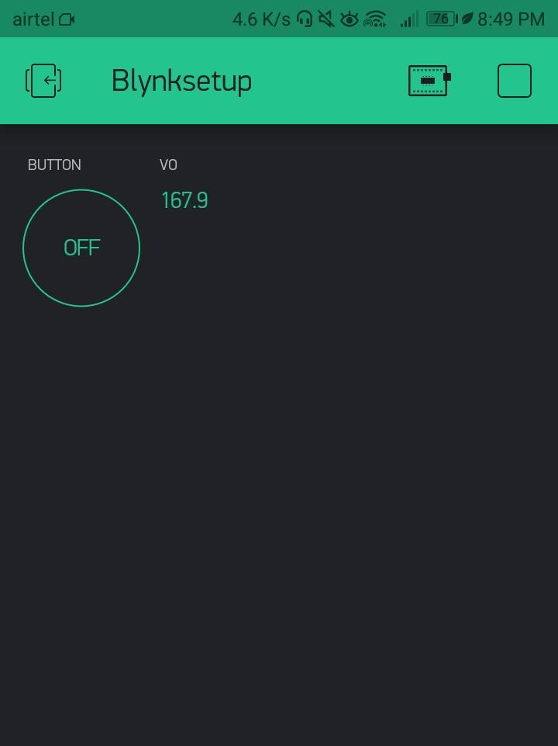

**Fig 1b**

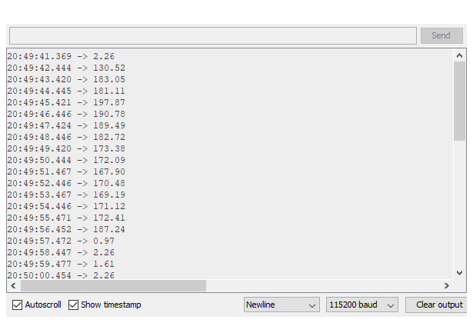

**Fig 1C**